**SOFTWARE ENGINEERING**

TEST PLAN DOCUMENT

**T Minus 0 Web Application**

**Project Team :**

IIB2019007 : Aditya Raj

IIB20190021 : Hitika Kumar

IIT2019018 : B Chetan Rao

IIB2019001 : Harsh Mahajan

Change Log

Version Date Modifications 1.0 03.04.2021

First versionTable of Contents

**TEST DOCUMENT: T Minus 0**

1: Introduction Section

2: Scope

3: Assumption/risks

4: Test approach

5: Unit testing (test cases)

a-)TEST CASE 1: Developer login

b-)TEST CASE 2:Add Doctor

c-)TEST CASE 3:Modify doctor details

d-)TEST CASE 4:Doctor login

e-)TEST CASE 5:Visualize model

f-)TEST CASE 6:Contact Developer

g-)TEST CASE 7:Update input stream

6: Integrated coupling

COUPLING

TEST CASE 1:

TEST CASE 2:

7: Found and fixed BUGS:

**1. Introduction**

The Test Plan has been created to communicate the test approach to team members. It includes the objectives, scope, schedule, risks and approach. This document will clearly identify what the test deliverables will be and what is deemed in and out of scope.

**1.1 Objectives**

“TMinus0” is aimed to analyze real time drift detection and analysis in massive medical data as well as provide healthcare services .It can do multi-patient analysis and store factual data for future research.

This can allow application of supervised models on data and also solve some critical problems like poor performance metrics result on real time medical data.

**2. Scope**

The initial phase will include all ‘must have’ requirements. These and any other requirements that get included must all be tested.

At the end of Phase 1, a tester must be able to:

a-)Transparency in course registration and profile updation

b-)Efficiency in communication between different departments

c-)Proper conduction of examination.

d-)User authentication is done using a LDAP server. System administrator enables/disables the user

account of LDAP server for access to AMS

e-)Updation/validation of marks regarding corresponding courses.

f-)Course management for students.

As the team works with the product they will define the needs for the second phase.

Load testing will not be considered part of this project since the user base is known and not an issue.

Rewriting, moving or porting existing test cases from the existing Word documents is not considered

part of this project.

**3. Assumptions / Risks**

3.1 Assumptions

This section lists assumptions that are made specific to this project.

1. Delivery of the product is in format that the test team can check it into CVS.

**3.2 Risks**

The following risks have been identified and the appropriate action identified to mitigate their impact on the project. The impact (or severity) of the risk is based on how the project would be affected if the risk was triggered. The trigger is what milestone or event would cause the risk to become an issue to be dealt with.

|  |  |  |  |  |
| --- | --- | --- | --- | --- |
| **#** | **Risk** | **Impact** | **Trigger** | **Mitigation Plan** |
| 1 | Scope Creep – as testers become more familiar with the tool, they will want more functionality | High | Delays in implementation date | Each iteration, functionality will be closely monitored. Priorities will be set and discussed by stakeholders. Since the driver is functionality and not time, it may be necessary to push the date out. |
| 2 | Changes to the functionality may negate the tests already written and we may lose test cases already written | High – to schedule and quality | Loss of all test cases | Export data prior to any upgrade, massage as necessary and re-import after upgrade. |
| 3 | Weekly delivery is not possible because the developer works off site | Medium | Product did not get delivered on schedule |  |
| 4 |  |  |  |  |

**4 Test Approach**

The project is using an agile approach, with weekly iterations. At the end of each week the requirements identified for that iteration will be tested.

Exploratory testing will play a large part of the testing as the team has never used this type of tool and will be learning as they go. Tests for planned functionality will be created and added to TCT as we get iterations of the product.

**4.1 Test Automation**

Automated unit tests are part of the development process, but no automated functional tests are planned at this time.

**5. UNIT TESTING:(TEST CASES)**

|  |  |  |
| --- | --- | --- |
| **TestCase No** | **Name** | **Test Case** |
| 1 | Developer login | Initial Login page to check if developers can log into T Minus 0 or not. |
| 2 | Add doctor | Developer should be able to add new doctor to Tminus0 |
| 3 | Modify doctor details | Developer should be able to modify doctor details |
| 4 | Doctor login | Initial Login page to check if doctor can log into T Minus 0 or not. |
| 5 | Visualize model | Doctor should be able to visualize model |
| 6 | Contact Developer | Doctor should be able to contact developer |
| 7 | Update input stream | Doctor should be able to change input stream and visualize model |

**TEST CASE 1:**

**STUDENT LOGIN:**

This is the initial login page to check if the developer can log in to the T Minus 0 or not.

After the developer has entered its login credentials, it must successfully log in the user to the landing page. When the developer, who is using the application, enters the credentials and clicks on the logIn’ button, then the developer is redirected into the next page, which is the developer dashboard.

This shows that the test case 1 is passed.

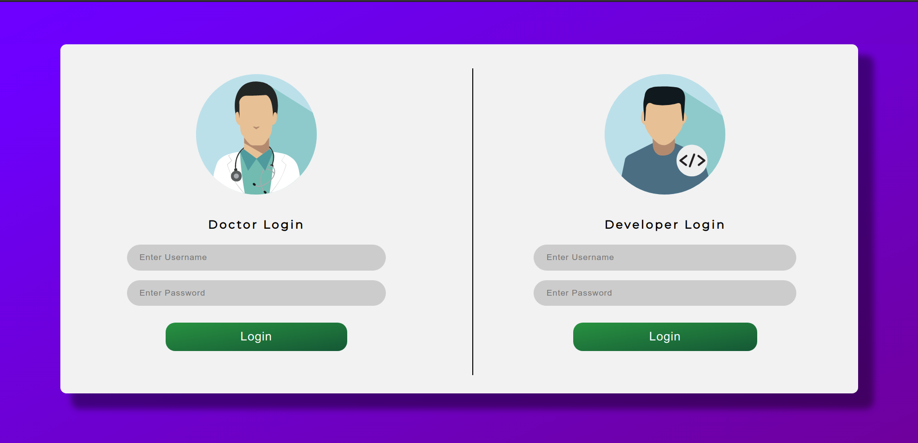

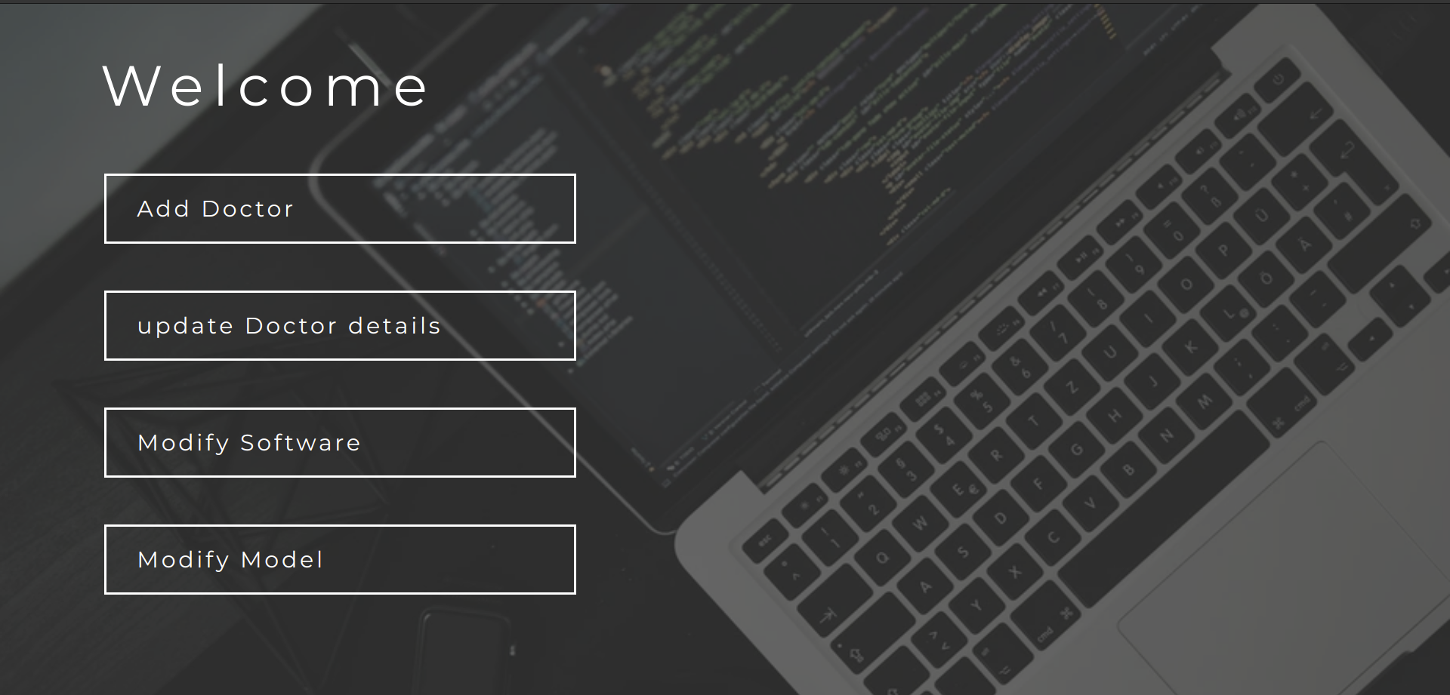

**TEST CASE 2**

**Add doctor**

This is the page for Developers to register a doctor. Registered doctor can login into Tminus0

This Shows that TEST CASE 2 has passed

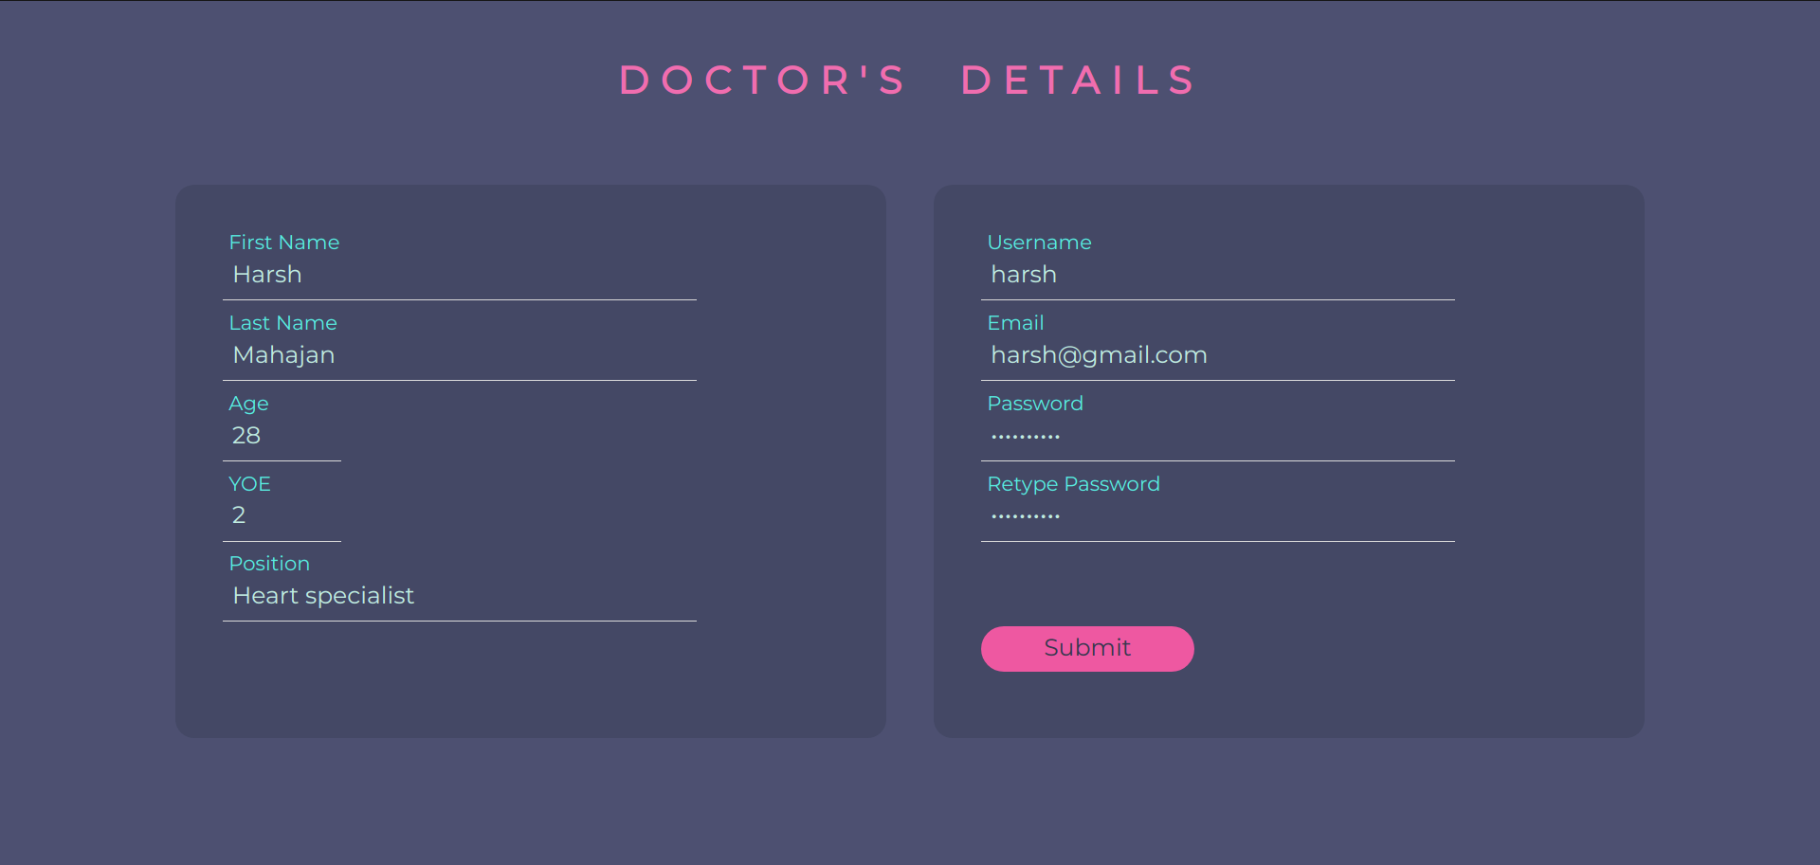

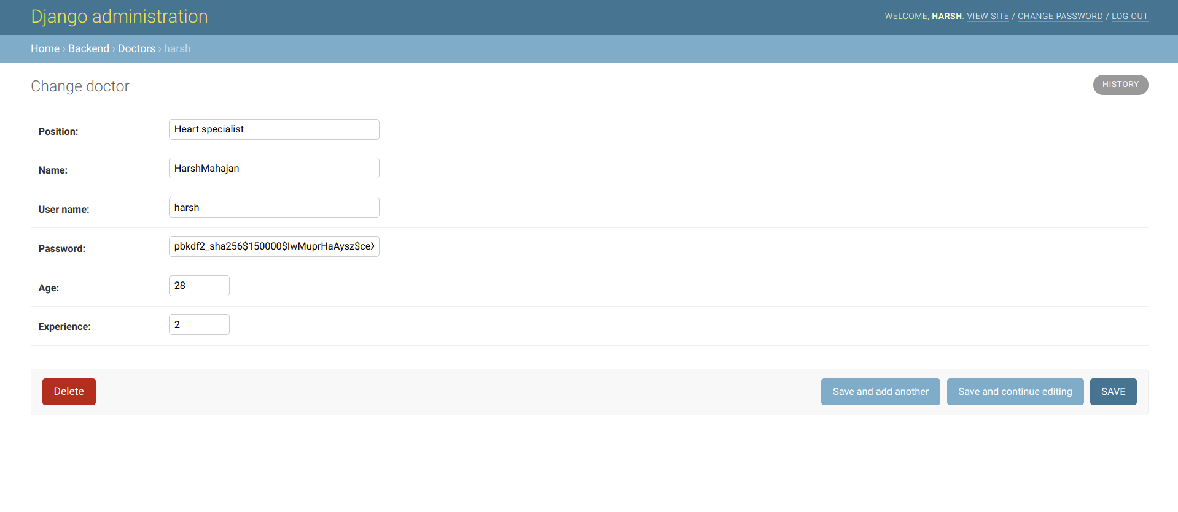

**TEST CASE 3**

**Modify Doctor Details:**

The developer should be able to modify the doctor details which is asked by the doctor.

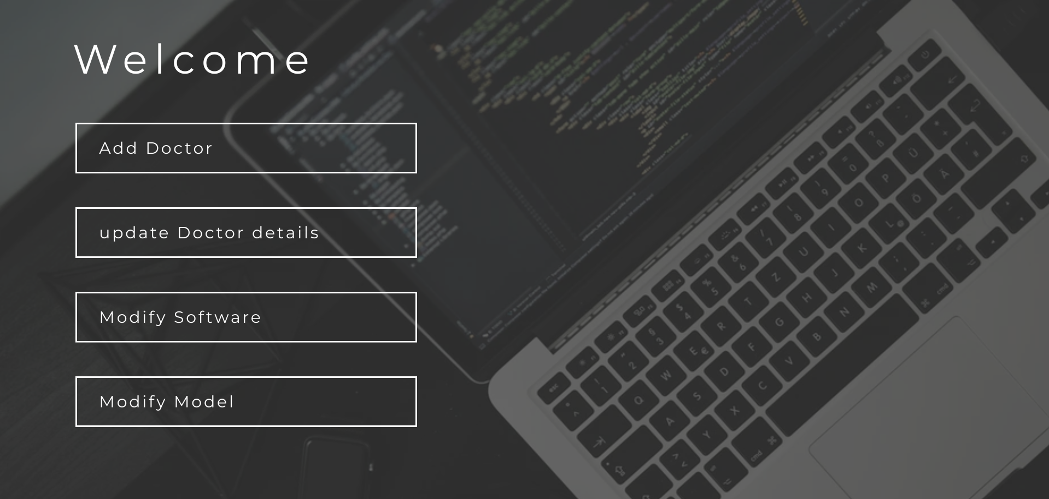

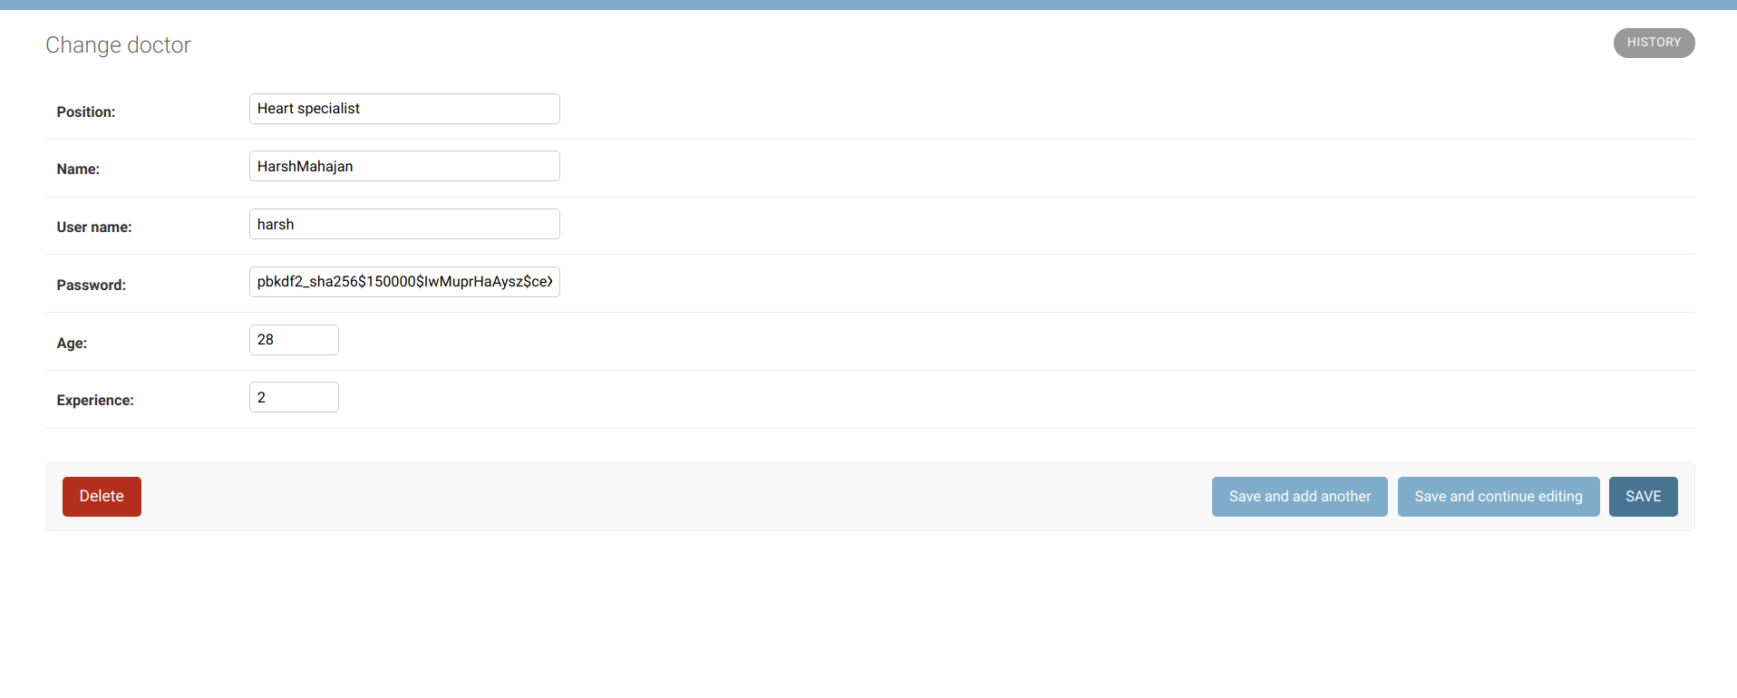

This Shows that TEST CASE 3 has passed.

**TEST CASE 4**

**Doctor Login**

This is the initial login page to check if the doctor can log in to the T Minus 0 or not.

After the doctor has entered its login credentials, it must successfully log in the user to the landing page. When the doctor, who is using the application, enters the credentials and clicks on the login button, then doctor is redirected into the next page, which is the doctor dashboard.

This Shows that TEST CASE 4 has passed

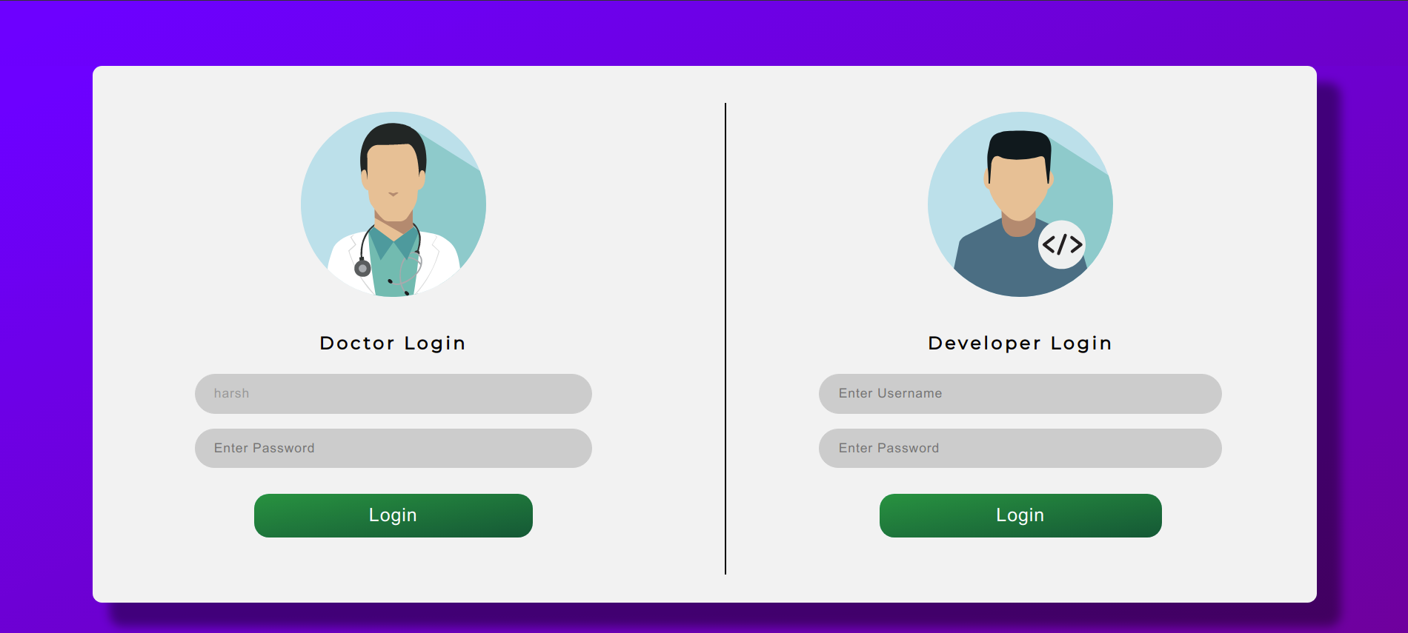

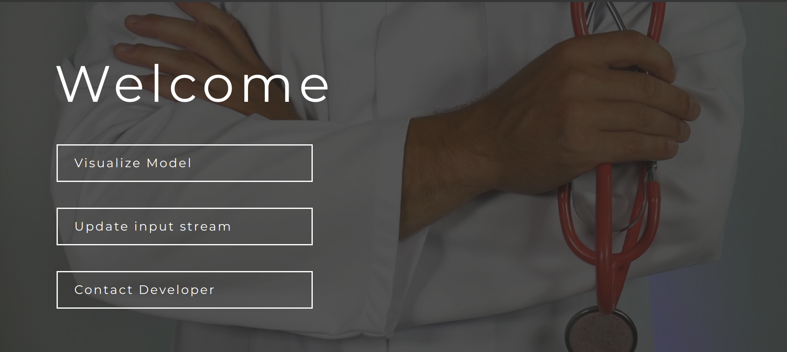

**TEST CASE 5**

**Visualize Model:**

Doctors should be able to visualize models by clicking on visualize models.

This shows that the test case 5 is passed.



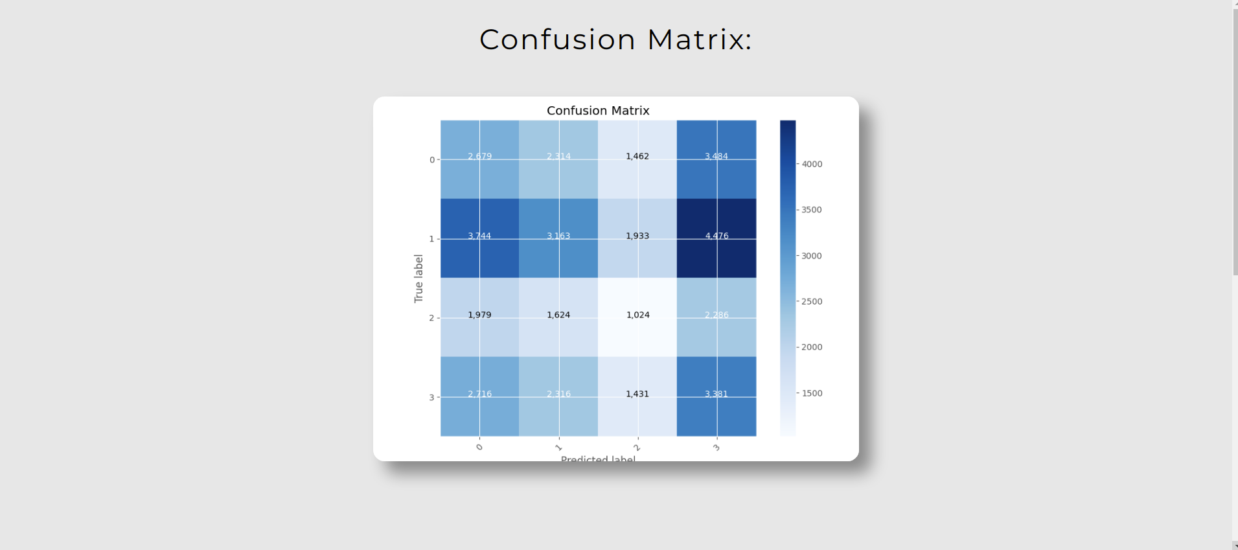

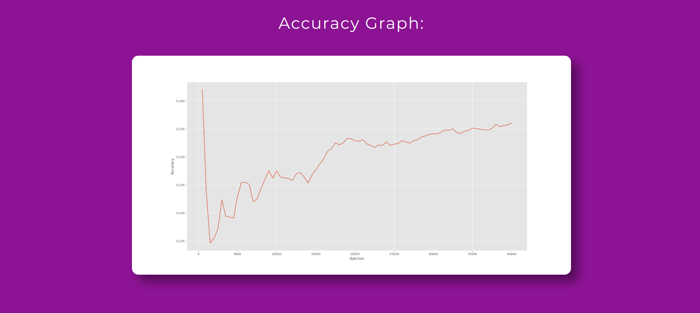

**TEST CASE 6**

**Contact Developer:**

This page is for Doctor to able to contact developer through there account

This Shows that TEST CASE 6 has passed.



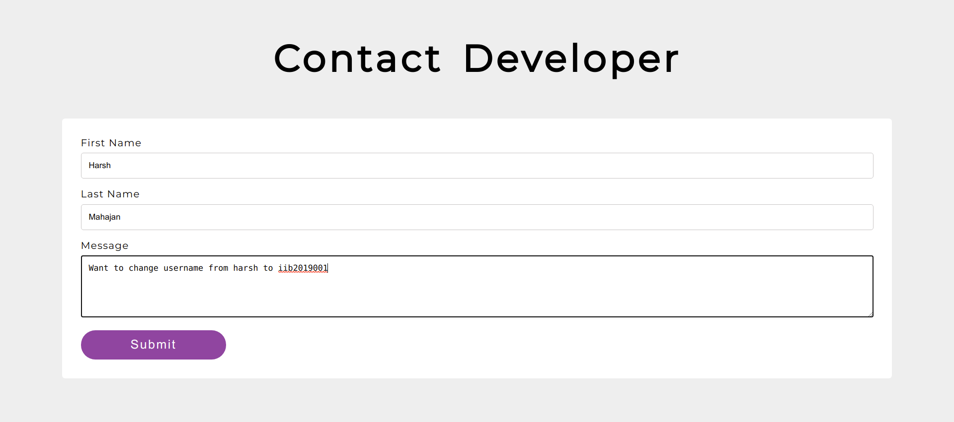

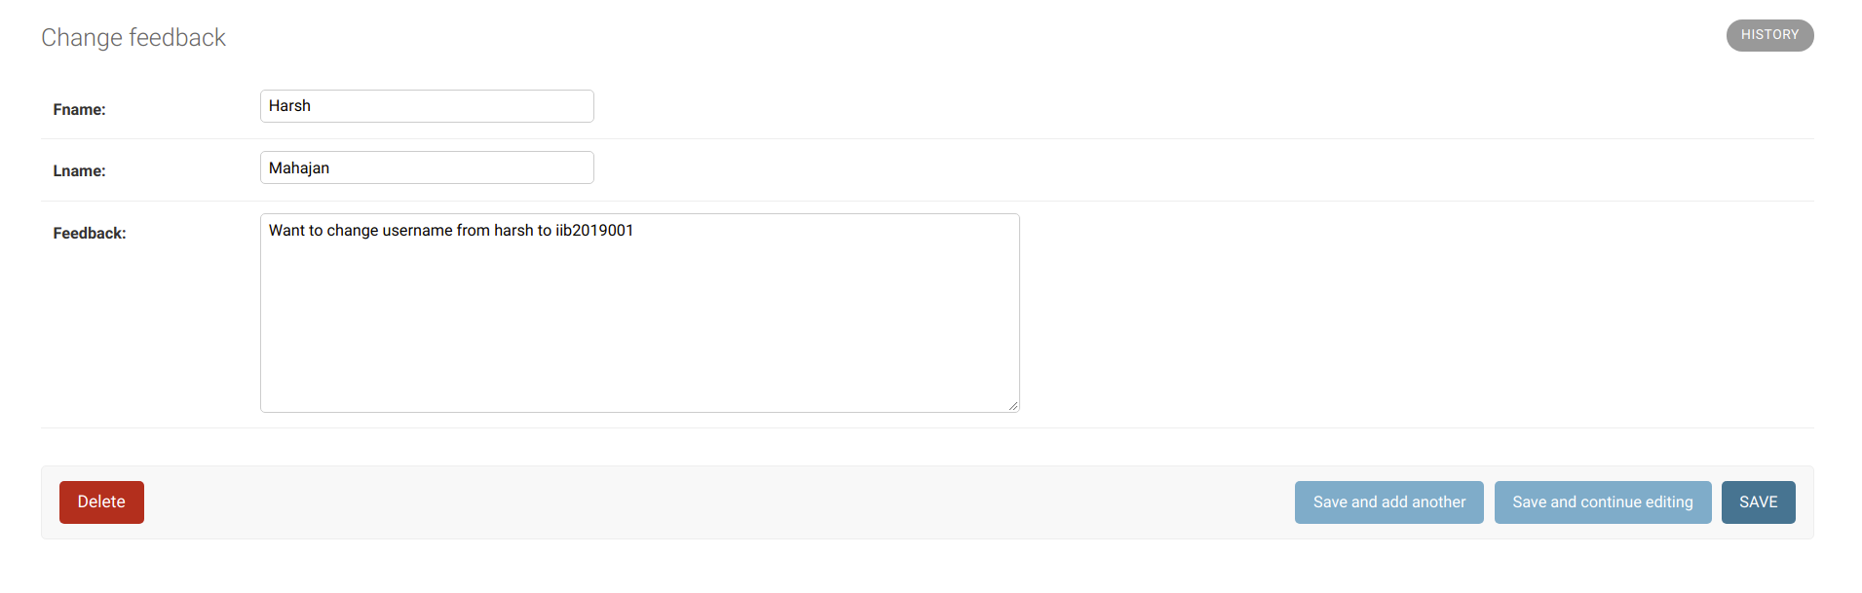

**TEST CASE 7:**

**Update input Stream:**

By clicking on update input stream Doctor should be able to upload File and then visualize the model.



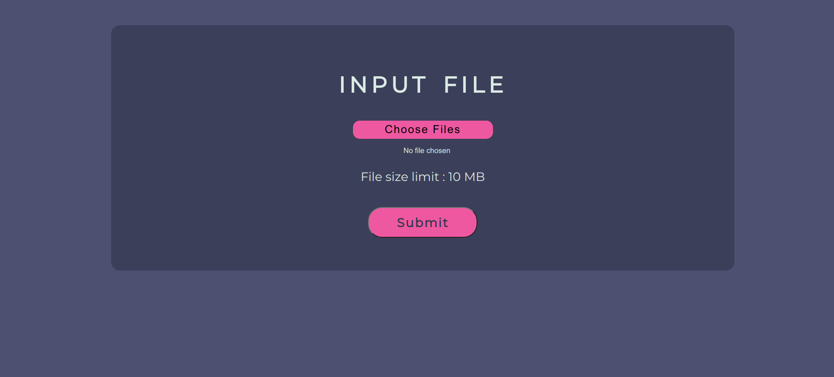

**Machine Learning Model Testing:**

Machine learning statistical testing is done by plotting a confusion matrix that predicts true positive, negative,f1 score etc..

For the model Deployment testing is done by serving different databases as input stream and observing different feature correlation graph for them per batches

**6: INTEGRATED TESTING**

Integration testing, also known as integration and testing, is a software development process in which program units are combined and tested as groups in multiple ways. In this context, a unit is defined as the smallest testable part of an application. In this section, Integration testing has been performed by considering different modules together to see how the module works together.

**COUPLING**

Coupling is the degree of interdependence between software modules; a measure of how closely connected two routines or modules are; the strength of the relationships between modules

**TEST CASE 1:**

Description:

We expect that as soon as the developer updates the doctor's profile, the doctor should be able to login to their account.

developer updating doctors. Doctors viewing updated changes.

If this works fine we can say test case 1 is passed.

**TEST CASE 2:**

Description:

We expect that as soon as the doctor updates the input data stream ,the respective changes/updates will be visible in the confusion matrix and model’s accuracy graph.

If this works fine we can say test case 2 is passed

**7. FOUND BUGS**

In this section, the bugs we found during the first execution of test cases are listed. Also the

fixes for bugs are listed. All bugs listed here are fixed

BUG 1

Description :While adding schedules, more than one schedule with the same instructor id could not be added.

Fix:Not to make instructor id the primary key.Keep a separate field for id and use it as primary key